HyperSlit: an ultralight hyperspectral UAV system for collecting plant spectral signature while recording sky spectra
Hamed Mehdipoor¹
¹Department of Advanced precision agriculture technology, Spectro-AG BV, Suetersweg 6A, 7497 MZ Bentelo, The Netherlands
Presenting author: Hamed Mehdipoor
Email Address: h.mehdipoor@spectroag.com
Telephone: +31(0)684706183
Keywords: Hyperspectral sensors, plant spectral signature, unmanned aerial vehicle
Hyperspectral remote sensing (HRS) is becoming a common technique to gain an insight into plant beyond the human eye. This is because HRS is a powerful proxy for the estimation of plant parameters (Bannari et al., 1995; Zhang et al., 2011). For example, plant water and chlorophyll content can be accurately derived from HRS measurements (Penuelas et al., 1997; Haboudane et al., 2002). Moreover, indices linked to diseases and photosynthetic apparatus can be retrieved from plants spectral signatures (PSS) (Delalieux et al., 2009). The PSS is defined as the variation of reflectance or emittance of a plant with respect to wavelengths. Therefore, HRS measurements are of high interest for plant biometeorology. For this purpose, calibrated, portable and non-destructive HRS systems are highly demanding to collect PSS over large areas.
Several biometeorological studies have been conducted by HRS systems that are mounted on unmanned aerial vehicles (UAV)(Delalieux et al., 2009; Primicerio et al., 2012). This is because UAV based HRS systems are tempting due to their great degree of automation and fast throughput (Suomalainen et al., 2014). The recent development of small and lightweight UAVs such DJI Mavic series (e.g., diagonal size is less than 40cm and weight is less than 1kg) offer affordable (about 1000 $) and stable flying platforms for HRS systems. However, there is no small HRS system that fits these UAVs to collect PSS while recording sky spectra. Sky spectrum is dynamically changing because the atmospheric condition is constantly changing. This makes the calculation of reliable reflectance information from plants challenging (Richter et al., 2002; Gao et al., 2009). To address this, in this paper we present HyperSlit system solution (Figure 1).
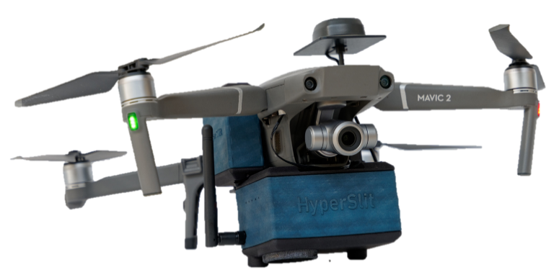
Figure 1. The HyperSlit system mounted on DJI Mavic 2 drone.
HyperSlit is a compact HRS system for small UAVs in the ultraviolet to near-infrared (UV/VIS/NIR) range (190–810 nm). This ultralight system relies on small open-source electronics and weighs a ready-to-fly 340 gr. HyperSlit was developed based on coaxial Ocean Optics STS micro-spectrometers and Sony CMOS RGB sensor which precisely localizes the Spectrometer FOV over selected targets in images captured by the system. The spectral resolution of collected data by HyperSlit is 0.5 nm that allows collecting high-resolution (1024 pixels) PSS. The two spectrometers of HyperSlit are synchronized for simultaneous plant and sky spectra collection. As a result, for each PSS recoded by HyperSlit, there is one sky spectra to be used for accurate calculation of reflectance from plants (Figure 2).
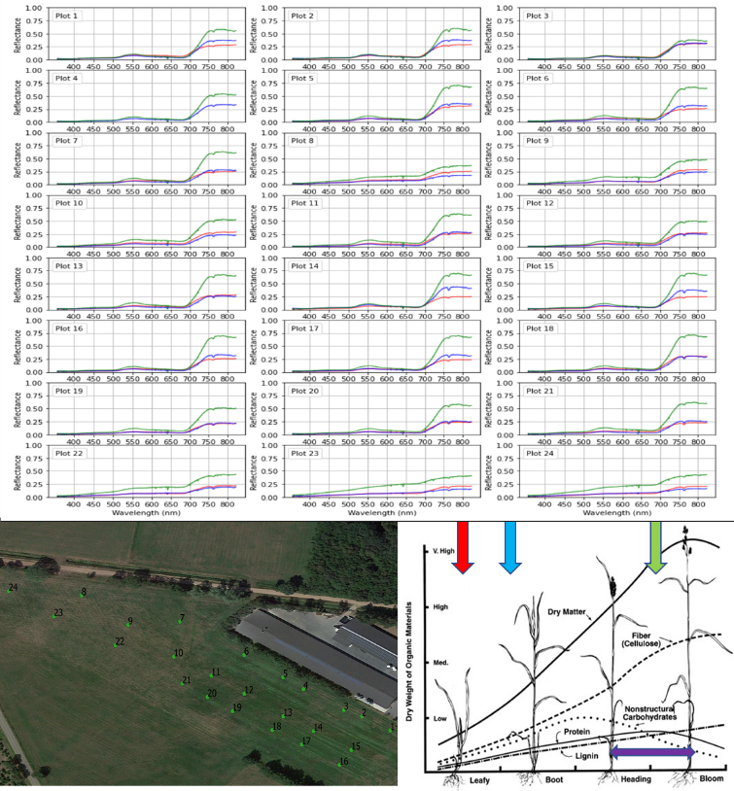
Figure 2. Spectral signature of plants at different growing stages.

HyperSlit has internal real-time kinematics global positioning system (RTK GPS) and inertial measurement units (IMU) sensors to record geographical and orientational parameters of the UAV per PSS. These parameters are used to qualify and map the collected data by HyperSlit at centimetre scale on the ground. HyperSlit has a web application (Web app) for monitoring, configuration, acquisition, correction and management of data. The app is available over the wireless network of the HyperSlit. The above-mentioned specification of HyperSlit offers on-the-fly and automatic 1)real-time monitoring, 2) setting the integration time of the sensors, 3) correcting optical dark charge and nonlinearity of sensor data, 4)calculating reflectance and 5) logging data on-the-fly and automatic ways. The functional system was tested in flight at a 10, 20, 30 and 40-m altitude over grasslands (Figure 3). The collected spectral signatures were used to analyse and model grassland traits such as crude protein in the Netherlands.

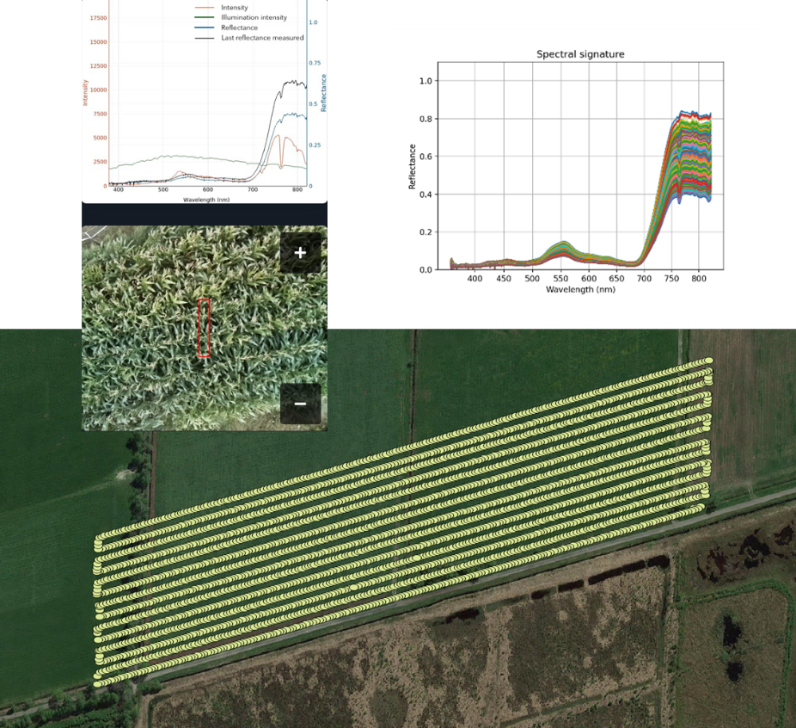
Figure 3. Geo-referenced locations of grass spectral signature.
The proposed hyperspectral UAV system took a step towards high-precision field spectroscopy and built a basic tool for hyperspectral research. HyperSlit is ultralight and compact and it provides dense and accurate geo-referenced PSS. This fills the gap between field spectroscopy and airborne sensors for plant biometeorology. Moreover, HyperSlit collects sky spectral from the same location where PSS is collected which is a unique feature that helps to collect precise PSS. Biometeorologists can use the system to create high-quality spectral libraries of plant conditions under various climate change scenarios. Processing such spectral libraries helps to acquire new knowledge as well as to train new models for plant parameters estimation.

References
Bannari, A., Morin, D., Bonn, F., & Huete, A. R. (1995). A review of vegetation indices. Remote Sens. Rev., 13(1–2), 95–120. https://doi.org/10.1080/02757259509532298
Delalieux, S., Somers, B., Verstraeten, W. W., van Aardt, J. A. N., Keulemans, W., & Coppin, P. (2009). Hyperspectral indices to diagnose leaf biotic stress of apple plants, considering leaf phenology. Int. J. Remote Sens., 30(8), 1887–1912. https://doi.org/10.1080/01431160802541556
Gao, B. C., Montes, M. J., Davis, C. O., & Goetz, A. F. H. (2009). Atmospheric correction algorithms for hyperspectral remote sensing data of land and ocean. Remote Sens. Environ., 113(SUPPL. 1). https://doi.org/10.1016/j.rse.2007.12.015
Haboudane, D., Miller, J. R., Tremblay, N., Zarco-Tejada, P. J., & Dextraze, L. (2002). Integrated narrow-band vegetation indices for prediction of crop chlorophyll content for application to precision agriculture. Remote Sens. Environ., 81(2–3), 416–426. https://doi.org/10.1016/S0034-4257(02)00018-4
Penuelas, J., Pinol, J., Ogaya, R., & Filella, I. (1997). Estimation of plant water concentration by the reflectance Water Index WI (R900/R970). Int. J. Remote Sens., 18(13), 2869–2875. https://doi.org/10.1080/014311697217396
Primicerio, J., Di Gennaro, S. F., Fiorillo, E., Genesio, L., Lugato, E., Matese, A., & Vaccari, F. P. (2012). A flexible unmanned aerial vehicle for precision agriculture. Precis. Agric., 13(4), 517–523. https://doi.org/10.1007/s11119-012-9257-6
Richter, R., Müller, A., & Heiden, U. (2002). Aspects of operational atmospheric correction of hyperspectral imagery. Int. J. Remote Sens., 23(1), 145–157. https://doi.org/10.1080/01431160010006908
Suomalainen, J., Anders, N., Iqbal, S., Roerink, G., Franke, J., Wenting, P., … Kooistra, L. (2014). A Lightweight Hyperspectral Mapping System and Photogrammetric Processing Chain for Unmanned Aerial Vehicles. Remote Sens., 6(11), 11013–11030. https://doi.org/10.3390/rs61111013
Zhang, T. T., Zeng, S. L., Gao, Y., Ouyang, Z. T., Li, B., Fang, C. M., & Zhao, B. (2011). Using hyperspectral vegetation indices as a proxy to monitor soil salinity. Ecol. Indic., 11(6), 1552–1562. https://doi.org/10.1016/j.ecolind.2011.03.025

The ratio of the amount of electromagnetic flux reflected by a surface to the total amount of electromagnetic flux incident on the surface
https://www.rijksoverheid.nl/onderwerpen/regio-deals/de-regio-deals-van-10-regios/regio-deal-twente

