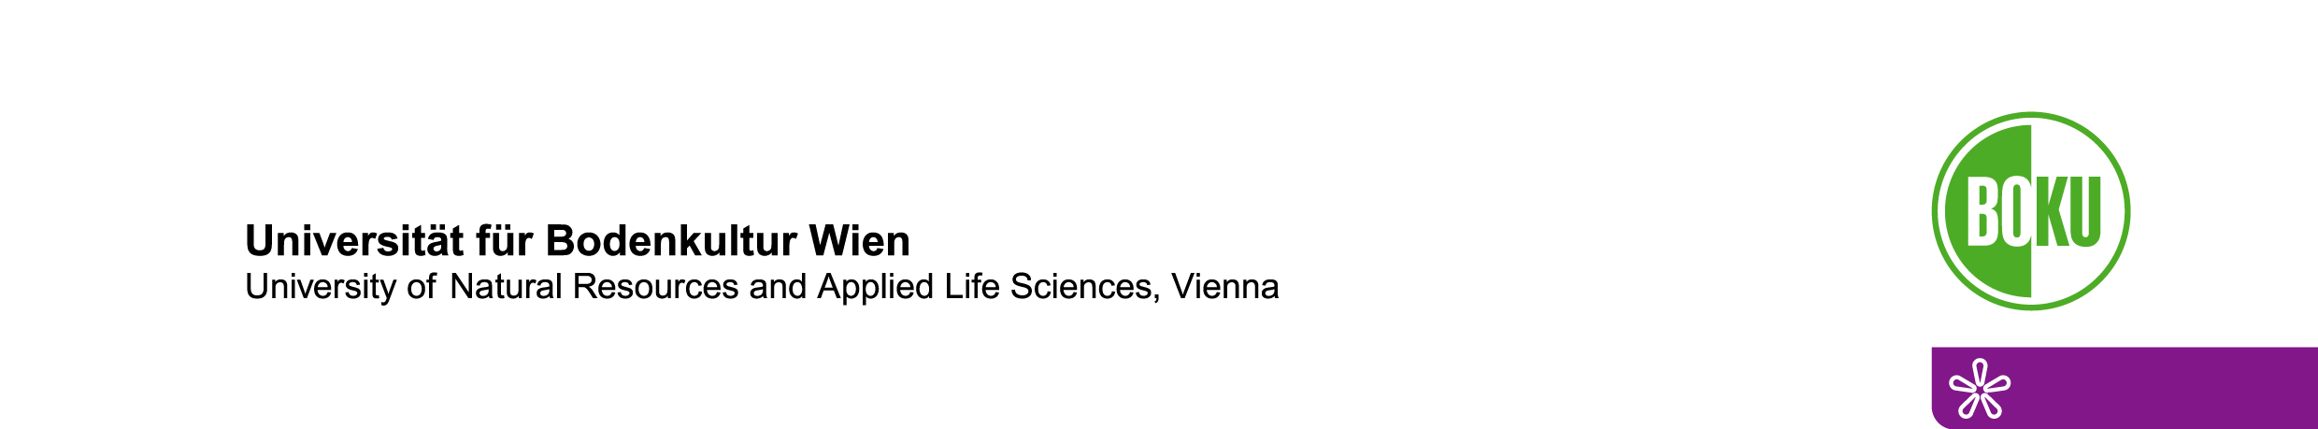

Postdoc-position in plant ecophysiology or related field

We are looking for a postdoctoral research associate at the Institute of Botany of the University of Natural Resources and Life Sciences (BOKU) Vienna, from Oct. 2020 to Nov. 2021. Focus of our group are plant ecophysiology, functional anatomy, stress physiology, global change, and ecology and ecophysiology of tropical plants. Candidates should have experience in one or several of these areas. Monthly income (gross) is min. € 3.889,50 (depending on previous work experience, 14x per year), social security and health care are covered. Vienna regularly comes out top on the list of the world's most liveable cities.

The candidate is expected to participate in research of the working group "Ecophysiology" and is encouraged to carry out own projects in this field. This includes supervision and co-supervision of master and PhD theses, teaching (in German and/or English) of courses in plant anatomy and ecophysiology, and active participation in BOKU self-administration. Given that this position is funded for only 14 months (maternity cover) we will encourage candidates to use this time to develop own projects for additional funding.

He/she should have a good command of English, international publications in the field, previous experience in research projects and in lab and fieldwork. Additional qualifications are proficiency in German, teaching experience, international postdoc experience, and good software and statistical skills.

Depending where candidates are located, interviews and selection will probably be done via online meetings in August.

Applications (see https://boku.ac.at/fileadmin/data/H01000/mitteilungsblatt-jobs/2020/KZ111_mD_EK.pdf) can be submitted in German or English to kerstin.buchmueller@boku.ac.at until July 29 quoting reference code 111 and should include:

• a CV with a detailed account of professional, teaching and research activities and a list of publications
• copies of 1-2 recent publications considered particularly representative,
• contact details of 2-3 referees

Informal inquiries can be sent to peter.hietz@boku.ac.at

Postdoc-position in plant ecophysiology or related field

We are offering a 6-year position for a postdoctoral research associate at the Institute of Botany of the University of Natural Resources and Life Sciences (BOKU) Vienna. Focus of our group are plant ecophysiology, functional anatomy, stress physiology, global change, and ecology and ecophysiology of tropical plants. Candidates should have experience in one or several of these areas. Monthly income (gross) is min. € 3.889,50 (depending on previous work experience, 14x per year), social security and health care are covered. Vienna regularly comes out top on the list of the world's most liveable cities.

The candidate is expected to participate in research of the working group "Ecophysiology" and to carry out own projects in this field. This includes submission, management and administration of third-party funded, competitive projects, supervision and co-supervision of master and PhD theses, teaching of courses in German and English, and active participation in BOKU self-administration. The position should ideally be filled in October 2020 but no later than the end of 2020.

He/she should have a good command of English and German, international publications in the field, previous experience in research projects and in lab and fieldwork in plant physiology. Additional qualifications teaching experience, international postdoc experience, and good software and statistical skills.

Applications (reference code will be available shortly) can be submitted in German or English to kerstin.buchmueller@boku.ac.at with the deadline likely 30.08.2020 and should include:

• a CV with a detailed account of professional, teaching and research activities and a list of publications
• copies of 1-2 recent publications considered particularly representative,
• a brief analysis (max. 1 page) of why you think you are particularly qualified for this position
• contact details of 2-3 referees

Informal inquiries (and questions as long as you don’t see an official announcement) can be sent to peter.hietz@boku.ac.at

